भारत का राजदूतावास, काहिरा
Embassy of India, Cairo
Economic and Commercial Report: DECEMBER 2017

OVERVIEW
Inside the issue

- Signs of economic revival evident in Egypt as macroeconomic indicators, including GDP growth, inflation, employment, FX reserves and external trade, recorded an upswing.
- Central bank of Egypt leaves its benchmark overnight deposit interest rate unchanged.
- Russia and Egypt ink the El Dabaa Nuclear power plant deal.
- Third installment (USD 2 bln) of the IMF loan approved.

MACROECONOMIC INDICATORS
- GDP growth revival
Egypt’s gross domestic product growth in the first quarter of the 2017/2018 (July-September 2017) financial year climbed to 5.2 percent from 3.4 percent the previous year according to the Planning Minister. Finance Minister Amr El Garhy had said earlier that the country expects an economic growth rate of between 5 and 5.25 percent in the current fiscal year ending in June 2018.
- Improvement in labour markets
According to the Central Agency for Public Mobilization and Statistics (CAPMAS), the unemployment rate during the third quarter of 2017 dropped to 11.9 percent, compared to 12.6 percent during the same period last year. Further, the number of jobless people reached 3.5 million of the total workforce, with an increase of 0.5 percent compared with the second quarter of the same year. Unemployment rates among females declined to 24.4 percent between January and March, compared to 25.9 percent within the same period in 2016, while the rates among males declined to 8.2 percent, compared to 8.5 percent last year.
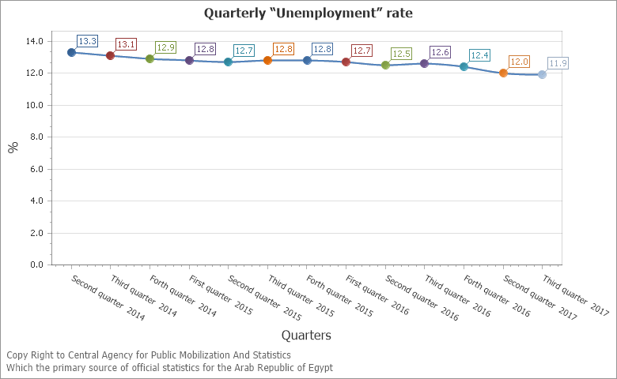

Inflation eases – Records the lowest price rise for the year
Central Bank of Egypt (CBE) reported that Egypt's core inflation dropped to 25.53% in November compared with 30.53% in October, on a year-over-year basis. Core inflation excludes volatile items such as food. Urban consumer prices increased 26% in November compared with 30.8% in the previous month. Inflation had shot up since the pound’s flotation last November, reaching a record high in July. However, on the back of energy subsidy cuts, it has gradually eased since.
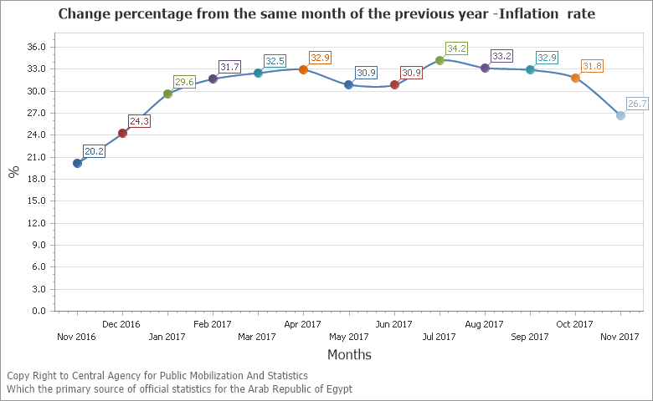
- Interest rate remains stable
The central bank of Egypt kept its benchmark overnight deposit interest rate unchanged at 18.75 percent for the fourth time on 28 December 2017, as widely anticipated. The overnight lending rate was also left steady at 19.75 percent, as a necessary requirement to achieve the inflation target of 13 percent (+/- 3 percent). Policymakers last hiked borrowing costs by 200 bps on July 06, 2017. Interest Rate in Egypt averaged 11.63 percent from 1991 until 2017, reaching an all time high of 21.40 percent in October of 1991 and a record low of 8.25 percent in September of 2009.
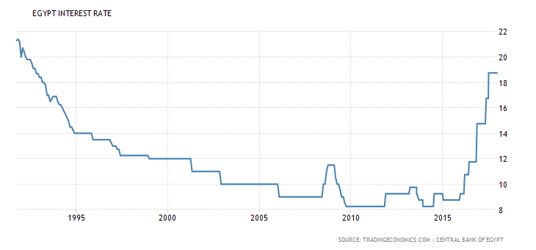
- Markets trading at all time highs
Egypt’s main stock exchange EGX 30 increased 20 points or 0.13% to hit an all time high of 15039 on January 2, 2018. The record low of 445.53 was recorded in January of 2002.
- FX reserves surpass the pre-2011 level peaks
Foreign Exchange Reserves in Egypt increased to 36725 USD Million in November from 36703 USD Million in October of 2017. Foreign Exchange Reserves in Egypt averaged 22970.25 USD Million from 2003 until 2017, reaching an all time high of 36725 USD Million in November of 2017 and a record low of 13448 USD Million in March of 2013.
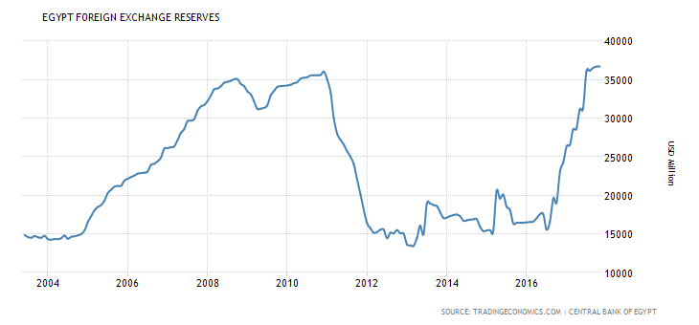

Business sentiment improving

Egypt PMI rose in November, reversing 25 months of decline. Emirates NBD Egypt PMI increases to 50.7 in November 2017 from 48.4 in October 2017. The survey is sponsored by Emirates NBD, Dubai's biggest bank by assets, and produced by IHS Markit, a financial information services company and includes purchasing managers from over 450 private sector companies.

External sector shows improved performance

Egypt recorded a BoP surplus of $5.1 bln in the period July-September 2017 (Q1 2017/18) compared to $1.9 bln in the same period last year according to the Central Bank
The improvement was driven by a 65.7% decrease in the current account deficit to $1.6 billion in Q1 2017/2018, compared to $4.8 billion in the same period of last fiscal year, the Central Bank said.
The trade deficit narrowed by 5% year-on-year, recording $8.9 billion. This came on the back of an increase in merchandise exports by 11% to $5.8 billion, driven by a 16.8% increase in oil exports to $1.8 billion in Q1 2017/2018 as well as an 8.6% year-on-year increase in non-oil exports to $4.1 billion.
BILATERAL RELATIONS
- Trade enquiries: During the month of December 2017, a total of 45 trade enquiries had been received, out of which 41 enquiries were from India and 04 from Egypt.
- Trade disputes: There were a total of 05 trade disputes, 04 of which were received from India and 01 of which was received from Egypt.
- Training Programmes: There were a total of (06) candidates joined ITEC Programmes in addition to (00) Candidates joined courses IAFS-III, (01) candidates for C.V. Raman and (00) candidates for AARDO programmes. (total 07)
Events
- Mr Sanjay Bhattacharyya, Ambassador of India to Egypt, inaugurated the Indian Pavilion of 10 leading Indian automobile component makers in Autotech 2017 which was held at Cairo International Convention Centre from 10-12 December 2017. The Pavilion was organized by the Engineering Export Promotion Council of India (EEPC) to showcase India’s OEM capabilities and scout for opportunities in Egyptian and North African markets. Inauguration also witnessed signing of an MOU between EEPC and the Engineering Export Council of Egypt to strengthen the bilateral cooperation between India and Egypt in the Engineering sector.
- Mr. Rubinder Singh, Director - Project Development, Kukuza Project Development Company (KPDC) visited Egypt from 6-10 December 2017 and met with Mr. Sanjay Bhattacharyya, Ambassador of India. The Embassy facilitated his meetings with Adm. Abdel-Kader Darwish, Deputy Chairman, Suez Canal Economic Zone and officials of World Bank in Cairo to discuss about development of Indian Zone in Suez Canal Economic Zone. KPDC is a Joint Venture company set up by Exim Bank of India, State Bank of India, Africa Development Bank and IL&FS Group to undertake project development activities for facilitating infrastructure development in Africa.
- Mr. Sirtaj Singh Bedi, Larsen & Toubro Limited, visited Cairo from 11-15 December. He met with Mr. Sanjay Bhattacharyya, Ambassador of India. The Embassy facilitated his meetings with Adm. Abdel-Kader Darwish, Deputy Chairman, Suez Canal Economic Zone, Mr. Ahmed Zohair, Director Head of Europe, Asia & America Region & Ms. Manar Waly Investment Promotion Officer (India - Malaysia) Promotion Sector at General Authority for Investment and Free Zones (GAFI) and officials from Federation of Egyptian Industries (FEI).
- On December 12, 2017, India Business Forum members met and interacted with Mr. Mohanad T. Khaled, Managing Partner BDO Khaled & Co., who briefed them about New Investment Law and executive regulations. The meeting was chaired by H.E. Sanjay Bhattacharyya – Ambassador of India to Egypt. Mr. Ajayy Kumar Singh, CEO DP World Sokhna also made a presentation on the expansion of Ain Shokna Port and DP World zone.
- Mr. Vishal Jadeja, Brucke Pharma India Pvt Ltd., visited Cairo from 17-19 December 2017 for exploring business opportunities with Egypt. He met with His Excellency Mr. Sanjay Bhattacharyya, Ambassador of India and the Embassy facilitated a meeting for him with Dr. Nagwa Borham, Head of Registration Sector, Holdi Pharma Company on 19th December 2017.
MARKET WATCH
- The International Monetary Fund approved the third installment of a $12 billion, three-year loan for Egypt, bringing the total released to date to just over $6 billion.
- Egypt has repaid a total of $4 billion of debt to the African Export-Import Bank, the Central Bank of Egypt. Further, Egypt's state-run news agency MENA reported that the central bank recently paid back $2 billion to the African Export-Import Bank out of a $3.2 billion short-term loan.

According to the Central Bank of Egypt (CBE), Egyptian banks have funded trade finance transactions worth 70.8 billion U.S. dollars since the government's decisions to float the Egyptian pound in November last year.

Egyptian expats remittances are at a record high level according to the Central Bank of Egypt. From November 2016 to November 2017, the total sum of remittances sent to Egypt from expats working abroad reached $24.2 billion. Remittances increased by 43 percent compared to the period of November 2015 to November 2016, which saw $17 billion in remittances sent to Egypt.
- The Egyptian Parliament approved a €225 million ($267 million) agreement that was previously signed between the Investment Ministry and the German KfW Development Bank to support the economic reform program. Germany’s KfW Development Bank is providing about €1.8 billion for ongoing projects in Egypt. The KfW Development Bank has financed the establishment of some 900 basic education schools and carried out water projects that have benefited around four million persons in the Delta governorates, in addition to irrigation projects that serve about seven million persons across Egypt, according to the Bank’s officials.
- Chinese investments in Egypt recorded $ 6 billion, including direct and indirect investments, China's Economic and Commercial Counsellor at the Chinese Embassy in Cairo Han Bing said. He made these remarks during the Egyptian Chinese Business Council, which is organized by the Federation of Egyptian Chambers of Commerce in cooperation with the Chinese Embassy in Cairo.
- Egypt’s New Urban Communities Authority (NUCA) approved the design of around 75 urban investment and services flagships in 15th of May City, South of Nile Delta, during 2017. The 75 projects will be established on a total space exceeding 32,000 feddans.
- Egyptian New Urban Communities Authority’s (NUCA) board also approved to allocate a number of land plots in the industrial zone of New El Alamein City, northwest of Cairo, for developers. The land plots are to be established over two million square metres in various phases, according to Egypt’s Housing Minister. The industrial developers are responsible for preparing the designs of road and utilities network and NUCA will execute a number of drinking water, sewage, and communication networks as well as road works and electricity grids within all the phases of the land plots.
- Egypt is experiencing a state of unprecedented stagnation on the domestic gold market as Egyptians have turned away from investing in gold recently, instead going for bank deposits with high interest rates as well as purchasing land plots and real estate, especially in the New Administrative Capital and new cities.
- The Egyptian cabinet approved a draft resolution by the board of governors of the World Bank's International Development Association (IDA) to increase Egypt's capital by $5.250 million. The Cabinet also ratified a presidential decree to increase Egypt's capital of the African Development Bank (AFDB) by $2 million.
- On November 26, 2017, the Egyptian Ministry of Finance issued a statement reiterating that November 29, 2017, all government institutions would stop processing paper checks drawn on the Central Bank of Egypt. Instead, as of December 1, 2017, all state financial transactions would be carried out using electronic payment and collection through the Government Fiscal Management Information System (GFMIS). The shift is expected to significantly enhance transparency and counter corruption, and represents a major step toward financial inclusion, which the World Bank defines as “individuals and businesses hav[ing] access to useful and affordable financial products and services that meet their needs — transactions, payments, savings, credit and insurance — delivered in a responsible and sustainable way.”
- Foreign investments in government treasury bills registered a new record high of about $18.849 billion at the end of October against $17.467 billion at the end of September with an increase of $1.382 billion, according to the Central bank of Egypt (CBE). Foreigners have been heavily investing in government debt instruments since the local currency was floated on November 2016.
- The total lending in Egyptian banks rose by 13 billion Egyptian Pounds at the end of September reaching 1.414 trillion pounds against 1.401 Pounds trillion at the end of August. Deposits rose to 3.176 Pounds trillion at the end of September against 3.124 trillion Pounds at the end of August, an increase of 52 billion Pounds.
- Egypt began production of undersea gas from the al Zohr gas field, which could possibly save $750 million to several billion dollars a year in energy costs. The al Zohr gas field has an estimated reserve of 30 trillion cubic feet and the first phase of production of 1.2 billion cubic feet per day is expected to be reached around mid 2018, with production being ramped up to 2.7 billion cubic feet per day by mid- to late 2019. Italy's ENI petroleum company is heading production of the al Zohr field, while BP is overseeing production of another large undersea gas field off Egypt's Nile Delta region, known as al Nooros.
- Russia signed a major deal with Egypt to proceed with the contracts for the construction of the El Dabaa nuclear power plant in Northern Africa. The signing ceremony was held in the presence of Russian President Vladimir Putin and his Egyptian counterpart Abdel Fattah El Sisi in Cairo on December 11. Russian state nuclear corporation Rosatom Director General Alexey Likhachev and Egypt’s Minister of Electricity and Renewable Energy Mohamed Shaker signed the contract according to which Rosatom will build four VVER-1200 units of the El Dabaa NPP in the Matrouh region on the Mediterranean coast, as well as supplying nuclear fuel throughout the plant’s entire operational lifetime. The first unit of the El Dabaa NPP is to be commissioned in 2026.As part of the El Dabaa NPP project implementation; Russia will also aid Egypt in developing its nuclear infrastructure, as well as increasing the level of project localization and supporting Egypt in training nuclear cadre and driving the public acceptance of nuclear power.
- Egypt’s President Abdel-Fattah El-Sisi inaugurated several development projects in the East Suez Canal development zone in northern Ismailia, including tunnels and two floating bridges to facilitate commercial and civilian access to Sinai and the East Suez Canal Development Zone. The East Suez Canal development project, which is part of the larger Suez Canal development plans, was launched in 2015. The project aims to develop major residential and industrial centres in the central Suez Canal governorate of Ismailia.

- According to the Suez Canal Authority the number of vessels traversing the Suez Canal in December 2017 witnessed an increase of 12.2 percent compared to December 2016, with a 15.8 percent increase in revenues in USD and an 11.7 percent increase in EGP. From January 2017 to December 2017, traffic increased 4.6 percent compared to same period last year, with a 5.6 percent increase in revenues in USD and 89.8 percent in EGP.
- The Suez Canal Economic Zone Authority signed seven contracts for projects with $40 billion in investments with several international companies at the World Youth Forum in Sharm El-Sheikh, according to the Al-Ahram Arabic news website. The deals include a $3.5 billion contract between a consortium of real estate companies and the Suez Canal Economic Zone Authority for the industrial development of 5.5 million square meters of land in Ain Sokhna. The consortium includes Ardak Development and Real Estate Investment, ASEC Engineering and Management, and Polaris Al-Zamil Industrial Park company, a joint venture between Polaris International Industrial Parks, a Turkish-Egyptian company, and Saudi-based Zamil-Holding investment company.
- An agreement for the $500 million financing of Sonker Bunkering Company and DP World Sokhna's liquid bulk terminal at Port Ain Sokhna was signed after long delays according to Al-Ahram Arabic news website. The terminal will be used to import and store gasoil and liquefied petroleum gas in the third basin of Port Ain Sokhna.
- Egypt’s President Abdel-Fattah El-Sisi inaugurated the Middle East’s largest fish farm in the country’s Kafr El-Sheikh governorate. The fish farm project, located on state-owned land in Berkat Ghalioun, is carried out by the armed forces in cooperation with China’s Evergreen Co following an agreement in July 2015. The project is being constructed at a total cost of EGP 4 billion.

(Fahad Ahmed Khan Suri)
Second Secretary (Commerce)
January 02, 2018

